Hope is Staying Awake and Woke
Isaiah 2: 1-5
Matthew 24:36-44

Othello Christian Church
December 2, 2018
Rev. Loren McGrail

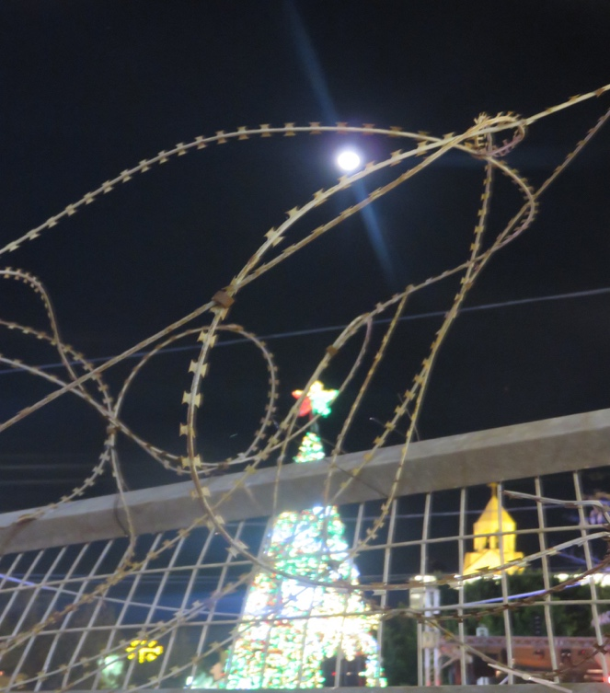

I love this time before Christmas---the hanging of the greens, the digging out of storage the Christmas decorations, the concerts, the parties, the streets all lit up. Each year in Jerusalem I would bring in my little live cedar bush and decorate it with lights and homemade ornaments. I would set up my creche made of sheep wool hoping Hind, my cat, wouldn’t steal or hide Jesus. Each year I left more and more of the embroidered decorations out because I just couldn’t let go of their beauty.
In the Holy Land, we got to celebrate Christmas three times because there are three different Christian groups: the Western church celebrates on the 24th and 25^{th,}, the Orthodox churches celebrate on January 6th and the Armenians usually around the 20th. Each time their Patriarch makes his traditional procession to Manager Square and the Church of Nativity to celebrate under the lights of the giant Christmas tree to the scouts marching bands playing bagpipes.
In contrast to these holiday festivities are these gloomy Advent texts calling us to prepare, watch, stay alert or awake.
Today’s lectionary text from the Book of Matthew imagines the coming of the Human One as a thief coming in the night.
So just as the days get longer and the light shorter, we are called to stay awake. Why or what are we staying awake for? The text says the Human One, the 2nd coming of Christ. These apocalyptic texts made sense back in the time of Matthew’s Gospel, but I am afraid don’t really make much sense to our modern ears, so I went on a hunt for what others had to say.
Well known theologian and preacher Barbara Brown Taylor says, “Advent invites us to awaken from our numbed endurance and our domesticated expectations to consider our life afresh in light of new gifts that God is about to give.” Have your expectations of what is possible become too domesticated? Have you become numb just trying to survive?
Like Taylor, Jesuit priest and martyr Alfred Delp, writing from his prison cell in Nazi Germany said, “Advent is a time for rousing. Human beings are to be shaken to the very depths, so that they may wake up to the truth of themselves. The primary condition for a fruitful and rewarding Advent, he said, “is renunciation, surrender…a shattering awakening; that is the necessary preliminary. Life only begins, he said, when the whole framework is shaken.”
Why is repentance and surrender always the first movement or primary condition? What has to die or be let go of in order for new life to come?
Why does the awakening need to be so violent? So dramatic? Has this happened to you? How did you survive the shaking? What did you have to leave or let go to make it through?
Matthew says the awakening will be like a thief in the night who breaks and enters. Our false securities will be broken so that truth can sneak in the back door. Stay awake not so you can guard against it but so that you go through the transformation, so you can welcome steadfast love which wants to be born in each of us. “Stay woke” to the way also that injustices intersect and divide us and keep us from this love.
This is the work of Advent spelled out in Isaiah’s vision of the healed world where bloody weapons would be turned into tools for work and nations would learn war no more. In the ancient world and in our world now, there is no authority, so nations take matters into their own hands. In Isaiah’s envisioned world God is the adjudicator of international disputes so war is not needed. The end of violence requires submission and the relinquishment of weapons, so the economy can be transformed by tools for production and life.

For out of Zion shall go forth instruction,
and the word of the Lord from Jerusalem.
He shall judge between the nations,
and shall arbitrate for many peoples;
they shall beat their swords into plowshares,
and their spears into pruning hooks;
nation shall not lift up sword against nation,
neither shall they learn war any more.

This one verse has inspired many throughout the world to seek ways for making peace instead of war which is why it is carved in stone in front of the UN in New York City.
In 1980 with the threat of first strike nuclear war hanging in the air Catholic priests and brothers, Daniel and Philip Berrigan, and 6 others started the Plowshares Movement under the influence of beating swords into plowshares. Like a thief in the night, unexpected, they broke into a GE weapons plant in Pennsylvania and damaged nuclear warhead mechanisms with hammers. Their action sparked a disarmament movement that has seen more than 80 nonviolent actions over the years.
This week the Vermont State Police which is responsible for law enforcement in approximately half of the northeastern state, and the police department in Northampton, Massachusetts, informed the Anti- Defamation League that they will not take part in the decades old program to have their police trained in the latest training in security strategies. Organizers against the militarization of local police forces cite the rising levels of police brutality and racism as their reason for withdrawal. Is not the choosing not to militarize your police force a form of choosing plowshares and prune hooks over more swords, saying No to study war?
In my own artistic way, I have turned weapons of destruction---tear gas canisters, stun grenades, sponge and rubber coated steel bullets into works of beauty and art. I used them to illustrate the context of the violence and brokenness of the world I lived in or the experiences I witnessed.
This first Sunday in Advent we light a candle of hope. I believe we cultivate or keep hope alive by staying awake to love’s shattering and unexpected entrance into our lives, and by staying woke to injustices wherever and whenever they crisscross our lives.
Towards understanding what the advent of the Human One can mean, I share this prayer/poem that I wrote from my overly lit and holiday decorated cottage in occupied Jerusalem:

Come Human One, advent our lives.
Come like a thief in the night and disturb
our sleep, our comfortable realities that say
you can have peace without justice,
that say taking someone else’s land or life is not our concern,
that says it is Ok to violate human rights,
break international laws.

Break into our lives, Son of Man,
challenge our certainties,
make us vulnerable to the urgency of your Call
for a new Jerusalem, a Beloved Community here and now
in this place where the streets still run with the blood of the martyrs, in this place all call holy, all call home.

Help us, unexpected One, to become insomniacs
to keep awake, alert, and watchful
for the ways that your coming can be thwarted, obscured, or denied
by theologies that privilege certain groups as Chosen
by peace processes that deny the right of return,
that don’t demand the freezing of settlement building
or walls that separate and divide.

Christ the thief, come take away our fears and insecurities.
Prepare our hearts, our minds, our spirits
for your indwelling presence
your incarnation as a baby, a refugee,
our brother, our redeemer.

May we become uneasy and alive
unafraid and able to hear angels announcing or singing.
May we become your advent lights
of hope, peace, faith, and love.

